**Week 3**

* A router keeps track of Network IDs
* Benefits of a router
  + Separates network logically into subnets; reduces network traffic as packets are only routed to their destination subnet
  + Isolates MAC broadcasts as it does not forward broadcast frames.
  + Connects different protocols: LAN protocols (e.g. Ethernet MAC) and WAN protocols (e.g. PPP).
* Benefits of static router
  + Enhance Security
    - Able to hide parts of an internetwork and specify only those parts that need to be revealed; dynamic routing tends to reveal everything known of an internetwork
    - Static route force traffic to take a specific, secure route instead of a route determined dynamically which can change as the network topology changes making traffic travel over an insecure route
  + Does not consume much traffic as no routing updates are transmitted
* Disbenefit of static router
  + Not suitable for large networks
    - Must know the entire network
    - Manually configure needed
  + Any change to the network means re-configuring all routers to reflect the change
  + Not be able to re-route the traffic if a link fails
* Outgoing interface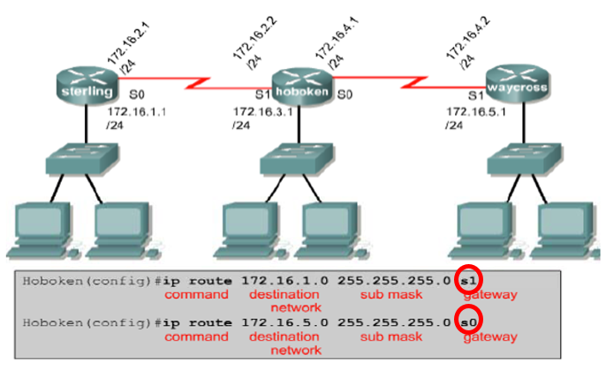
* Next-hop address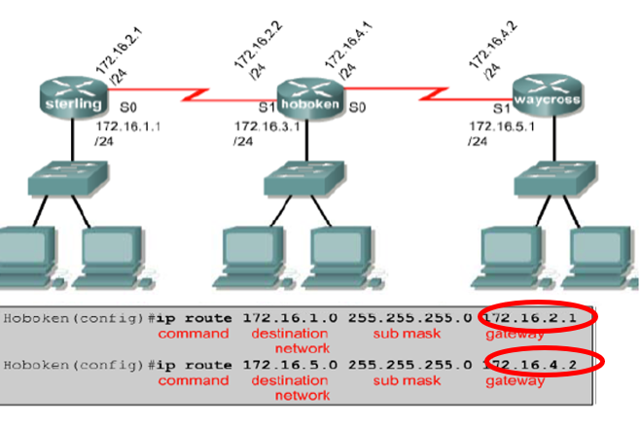
* show running-config is used to view the active configuration in RAM
* show ip route command is used to make sure that the static route is present in the routing table

**Week 4**

* Dynamic routing protocols
  + Routing Information Protocol (RIP) / distance vector
    - Use hop count as routing metric
    - Max hop: 15
    - Update routing table every 30 sec; create lot of overhead traffic
    - 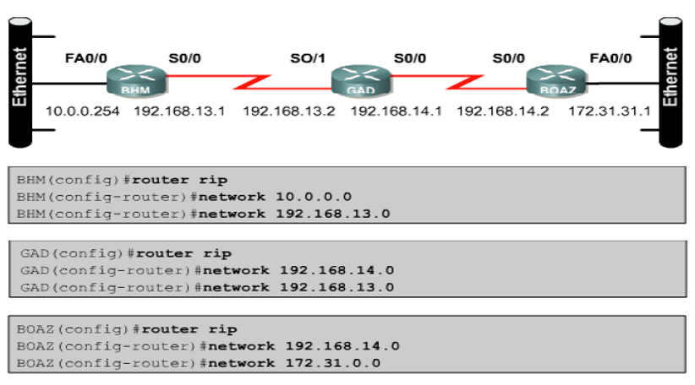
  + Open Shortest Path First (OSPF) / link state
    - Use **cost** as metric
      * Cost is based on a variety of factors such as speed (bandwidth), reliability and delay
    - Compare to RIP
      * Less bandwidth-intensive
      * Faster convergence time (react quickly to topology changes)
      * More CPU and memory resources required
* Command
  + Show ip protocol monitor IP packer flow
  + Show ip route show the route table
* Benefit
  + Simpler to configure routers on large networks
  + Routes are automatically discovered and maintained by routers, reducing administrative effort
  + Router can respond automatically to topology changes such as new or deleted routes
  + Automatic re-routes enable network to be resilient

Week 5

* Ipconfig
  + Provides the necessary information about the computer network.
* ping
  + To test a host on the TCP/IP network is reachable
* tracert
  + To know the route that the IP packets travelled from one router to another
* nslookup
  + To querying the Domain Name System (DNS) to obtain
    - Domain name
    - IP address mapping
    - Any other specific DNS record
* Netstat
  + To displays network connections (both incoming and outgoing), routing tables, and a number of network interface statistics
* telnet
  + Remote access to remote computer (client to connect to server)
* SSH
  + Same as telnet but connection is encrypted
* route print
  + Display route table and interface list

Week 6

* No of required subnet <= (2^ subnet bit) -2
* No of usable host = (2^ subnet bit) -2

Week 7

* LAN = one broadcast domain
* Benefits of VLAN
  + control network broadcasts without having to use routers
  + allow users to be assigned by network admin
  + better network security by defining which nodes can communicate with each other
* VLAN method
  + Static
    - Assigned to a port
    - Easy configure and monitor
  + Dynamic
    - Assigned to a mac address/ protocol type
    - No need to reassign when moved
* Trunk
  + Trunk is place between 2 switch which use for inter-switch VLAN communication
  + Allow a VLAN from one switch to communicate with another switch of the same VLAN group
  + Frame tagging
    - By IEEE 802.1Q
    - Assigns a VLAN ID to each frame before forward to trunk
    - Removed after leaving the trunk
* Inter-VLAN routing
  + Allow a VLAN group to communicate with another VLAN group
  + A router is needed

Week 11-13

* Active directory
  + **Provides a directory services** infrastructure that can help organizations manage resources throughout the network.
  + To provide simplified and efficient system administration
* 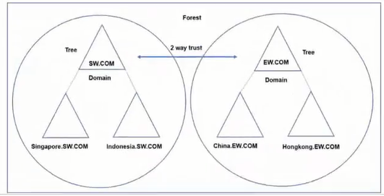
* Group account type
  + Distribution
    - For email
  + Security
    - Assign permissions or user rights to group that need access to resources.
* User group  
  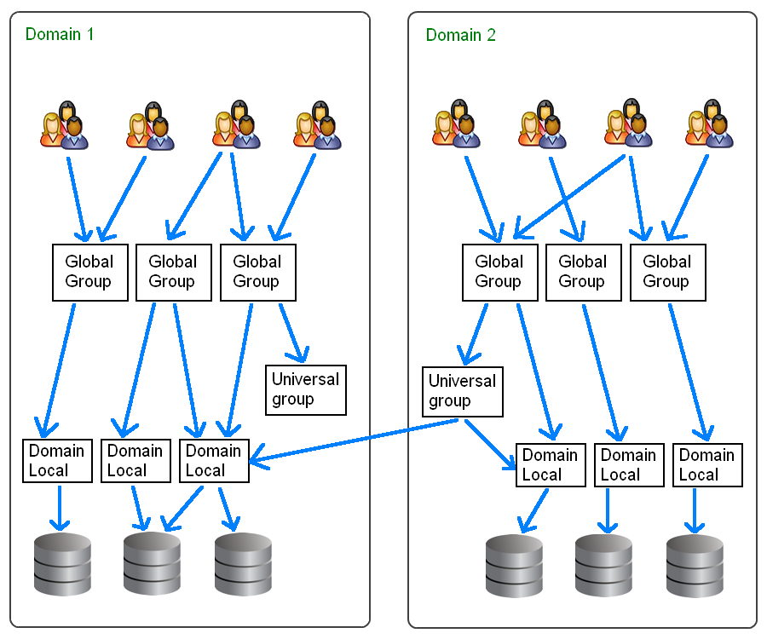
* NTFS permission  
  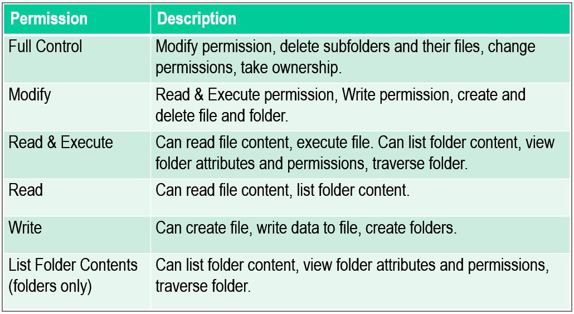
* Deny have a bigger right than allow permission
* Share permission
  + Inherited and addon to the NTFS permission
  + Cannot give share permission of what NTFS permission did not give
  + Only apply to user who accessing over the network
  + Apply to folder, not a file
  + To access a share folder with Run, \\ServerName\ShareName
* Add $ symbol to the back of the hide folder name to hide it